**Inode in File System of Linux:**

An inode is an entry in inode table, containing information (the metadata) about a regular file and directory. An inode is a data structure on a traditional Unix-style file system such as [ext3 or ext4](https://linoxide.com/how-tos/explained-in-detail-linux-ext2-ext3-and-ext4-filesystem/). Linux extended filesystems such as ext2 or ext3 maintain an array of these inodes: the inode table. This table contains list of all files in that filesystem. The individual inodes in inode table have a unique number (unique to that filesystem), the inode number. Diving deep into the inode, an inode stores:

* **File type:** regular file, directory, pipe etc.
* **Permissions to that file:** read, write, execute
* **Link count:**The number of hard link relative to an inode
* **User ID:** owner of file
* **Group ID:** group owner
* **Size of file:** or major/minor number in case of some special files
* **Time stamp**: access time, modification time and (inode) change time
* **Attributes:** immutable' for example
* **Access control list:** permissions for special users/groups
* **Link to location of file**
* **Other metadata** about the file

Here we will be using the command “chmod +x” to execute the file. I have explained “chmod” briefly in the file permission experiment. The use of this along with the filename makes the file executable. “./” runs this executable file. In the following screenshot, I have made a file in the VI editor whose inode number I want to know. In another while I have written 3 ways in which we can find the inode number of the file.

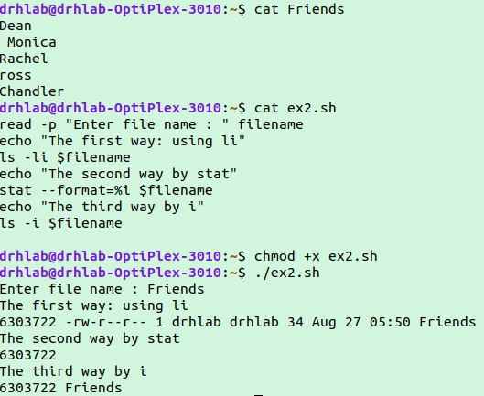

Even after editing the inode number of the file remains the same.

